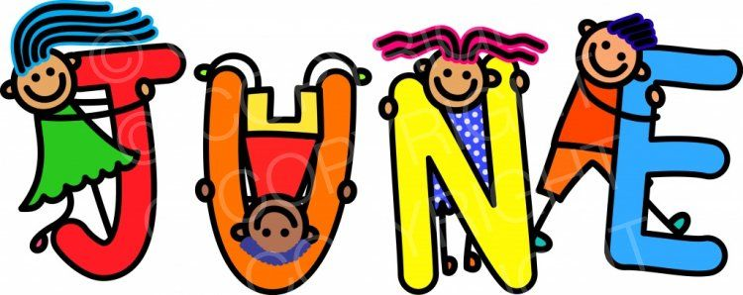
Pecos Independent Schools
Breakfast/ Lunch Menu
Summer Camp
In accordance with Federal law and USDA policy, this institution is prohibited from discrimination on the basis of race, color, national origin, sex, age or disability.

Sunday | Monday | Tuesday | Wednesday | Thursday | Friday | Saturday
 |  |  | 1 | 2 | 3 | 4
5 | 6 | 7 | 8 | 9 | 10 | 11
 | Breakfast:  Cereal Fruit & milk  Lunch:  Corn dogs Baked beans, gold fish, fruit, & milk | Breakfast:  Bagel W/ cream cheese, fruit, & milk  Lunch:  Chicken Tenders W/BBQ sauce, fries, veggie, fruit & milk | Breakfast:  Breakfast burrito, salsa, fruit &milk  Lunch:  Pizza, Salad Fruit, & milk | Breakfast:  French toast, syrup, fruit, &milk  Lunch:  Bean & cheese Burrito w/ red chili, veggie, fruit & milk | Breakfast:  Cinnamon rolls, fruit & milk  Lunch:  Chicken Sandwich, tater tots, lettuce,  tomatoes, fruit & milk
12 | 13 | 14 | 15 | 16 | 17 | 18
 | Breakfast:  Cereal Fruit & milk  Lunch:  Turkey sandwich lettuce, tomatoes, fruit chips & milk | Breakfast:  Breakfast pizza  Fruit & milk  Lunch:  Fajitas w/ red green bell peppers on tortilla, salsa, rice, fruit &milk | Breakfast:  Peanut butter n jelly sandwich, fruit & milk  Lunch:  Cheese Burgers fries, lettuce, tomatoes, fruit & milk | Breakfast:  Sausage Biscuit, fruit & milk  Lunch:  Beefy Macaroni, roll, green beans, fruit, & milk | Breakfast:  Cereal Fruit & milk  Lunch:  Chicken Quesadilla Salsa lettuce tomatoes, chips fruit & milk
19 | 20 | 21 | 22 | 23 | 24 | 25
 | Breakfast:  Cereal Fruit & milk  Lunch:  Chicken Tacos, Beans lettuce, tomatoes, fruit & milk | Breakfast:  Cheese Quesadilla, salsa, fruit & milk  Lunch:  Frito pies, Lettuce, tomatoes Fruit, &milk | Breakfast:  Muffin, cheese sticks, fruit & milk  Lunch:  BBQ Pork Sandwich veggies, chips, fruit & milk | Breakfast:  Yogurt, granola, fruit &milk  Lunch:  Ham & cheese Chips lettuce tomatoes fruit & milk | Breakfast:  Cereal Fruit & milk  Lunch:  Buffalo wings, potato salad, celery Ranch fruit & milk | 